Ex1a: Text Generation using N-gram Language model

Learning Objective:
Implement an N-Gram–based predictive text model using bigram and trigram probability distributions. This helps to understand how contextual probability influences next-word prediction.

Steps:
- Initialize the environment by installing and importing the Natural Language Toolkit (nltk). Download the Brown Corpus (for text data) and the Universal Tagset (for simplified Part-of-Speech tags).
- Extract raw sentences from the Brown Corpus using brown.sents().
- Tokenization: Convert all words to lowercase and flatten the nested list into a single list of tokens to verify the total volume of training data.
- Build an N-Gram Model for Bigram and Trigram.
- Predict Next Word and display Top-5 Suggestions
- Test Bigram & Trigram Prediction on certain words.

Program:
import nltk
from nltk.corpus import brown
from collections import defaultdict, Counter

nltk.download('brown')

class NGramPredictor:
def __init__(self, n=3):
"""
Initialize the N-Gram model.
n: The 'n' in n-gram. n=3 means Trigram (look at 2 previous words).
"""
self.n = n
self.model = defaultdict(Counter)

def train(self, corpus_sentences):
"""
Builds the n-gram frequency dictionary.
corpus_sentences: list of list of words.
"""
print(f"Training {self.n}-gram model on {len(corpus_sentences)} sentences...")

for sentence in corpus_sentences:

sentence = [word.lower() for word in sentence if word.isalpha()]

for i in range(len(sentence) - self.n + 1):
ngram = tuple(sentence[i : i + self.n])
context = ngram[:-1]
target = ngram[-1]

self.model[context][target] += 1

print("Training complete.")

def predict(self, text, top_k=3):
"""
Predicts the next word based on the input text.
"""

words = [w.lower() for w in text.split() if w.isalpha()]

context_length = self.n - 1

if len(words) < context_length:
return f"Need at least {context_length} words for context."

context = tuple(words[-context_length:])

if context in self.model:
possible_next_words = self.model[context]

total_count = sum(possible_next_words.values())

top_words = possible_next_words.most_common(top_k)

results = []
for word, count in top_words:
prob = count / total_count
results.append((word, round(prob, 2)))
return results
else:
return None

corpus = brown.sents(categories='news')

predictor = NGramPredictor(n=3)
predictor.train(corpus)

test_phrases = [
"The jury said",
"The city executive",
"He was",
"In the"
]

print("\n--- Predictions ---")
for phrase in test_phrases:
prediction = predictor.predict(phrase)
if prediction:
print(f"Context: '{phrase}' -> Predictions: {prediction}")
else:
print(f"Context: '{phrase}' -> No prediction found (Unseen context).")

Output:

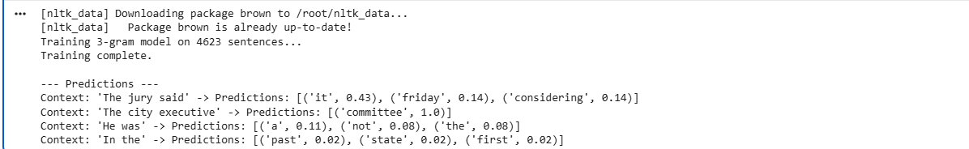

Learning Outcome:
Upon completion of this experiment, the bigram and trigram probability distributions for next-word prediction was implemented and evaluated using the Brown Corpus.

Ex1b: Hidden Markov Model (HMM) based Predictive Text System

Learning Objective:
To implement a predictive text system using Hidden Markov Model (HMM), enabling students to understand contextual probability, POS transitions, and next-word prediction using the Brown Corpus.

Steps:
- Initialize the environment by installing and importing the Natural Language Toolkit (nltk). Download the Brown Corpus (for text data) and the Universal Tagset (for simplified Part-of-Speech tags).
- Extract raw sentences from the Brown Corpus using brown.sents().
- Tokenization: Convert all words to lowercase and flatten the nested list into a single list of tokens to verify the total volume of training data.
- Load the tagged version of the corpus (brown.tagged_sents) which provides the "Hidden States" (POS tags) linked to the "Observations" (words).
- Train the HMM Model. Use the HiddenMarkovModelTrainer to perform Supervised Learning. Calculate the internal parameters of the HMM: Initial State Probabilities, Transition Probabilities, Emission Probabilities
- Build POS Transition Probabilities
- Build Emission Probabilities
- Define Prediction Function
- Test the Model
- Verify POS prediction on certain words.

Program:

import nltk
import numpy as np
from collections import Counter
import re
from hmmlearn import hmm

nltk.download('brown')
nltk.download('punkt')
from nltk.corpus import brown

print("Loading Brown Corpus...")
sentences = brown.sents()

VOCAB_SIZE = 2000
UNK_TOKEN = "<UNK>"

print("Building Vocabulary...")

all_words = [word.lower() for sent in sentences for word in sent if re.match(r'^[a-z]+$', word)]

word_counts = Counter(all_words)
most_common = word_counts.most_common(VOCAB_SIZE - 1) # -1 to save room for UNK
vocab = {word for word, count in most_common}
vocab.add(UNK_TOKEN)

word_to_id = {word: i for i, word in enumerate(sorted(vocab))}
id_to_word = {i: word for word, i in word_to_id.items()}
unk_id = word_to_id[UNK_TOKEN]

print(f"Vocabulary limited to {len(vocab)} words (optimized for speed).")

print("Encoding sequences...")
sequences = []
lengths = []
X_list = []

for sent in sentences[:5000]:
seq = []
for word in sent:
w_lower = word.lower()
if not re.match(r'^[a-z]+$', w_lower): continue

# Use specific ID if word in vocab, else use UNK ID
idx = word_to_id.get(w_lower, unk_id)
seq.append(idx)

if len(seq) >= 2:
sequences.append(seq)
lengths.append(len(seq))
X_list.extend(seq)

X = np.array(X_list).reshape(-1, 1)

# 3. TRAIN HMM
# ==========================================
print(f"Training HMM on {len(X)} tokens...")
# n_components=10 is enough for a quick test. Increase to 50 later if needed.
model = hmm.CategoricalHMM(n_components=10, n_iter=10, random_state=42, verbose=True)
model.fit(X, lengths=lengths)

print("✅ HMM training completed!")

def predict_next_word(context_words, top_k=3):
"""Predicts next word using the trained HMM"""

context_ids = [word_to_id.get(w.lower(), unk_id) for w in context_words]

if not context_ids: return []

logprob, state_path = model.decode(np.array(context_ids).reshape(-1, 1), algorithm="viterbi")
last_hidden_state = state_path[-1]

# 2. Look at the Transition Matrix: What hidden state comes next?
next_state_probs = model.transmat_[last_hidden_state]
best_next_state = np.argmax(next_state_probs)

# 3. Look at Emission Matrix: What word does that next state emit?
emission_probs = model.emissionprob_[best_next_state]

# Get top K words
top_indices = np.argsort(emission_probs)[-top_k:]

results = []
for idx in reversed(top_indices):
word = id_to_word[idx]
prob = emission_probs[idx]
if word != UNK_TOKEN:
results.append((word, prob))

return results

# 5. TEST

test_phrases = ["the teacher", "good", "united", "he", "she"]

print("\n--- Predictions ---")
for phrase in test_phrases:
preds = predict_next_word([phrase])
print(f"Input: '{phrase}' -> Predicted: {preds}")

Output:
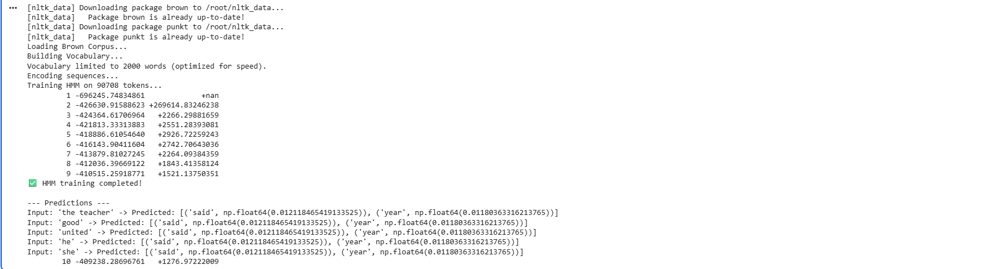

Learning Outcome:
Upon completion of this experiment, HMM based model was built to predict the next word with POS-based suggestions, and evaluated the effectiveness of context-driven predictive text generation using the Brown Corpus.

